# Adding professional skills to your resume

Technical skills are crucial when building a solid resume. They demonstrate to employers that you have the professional skills necessary to successfully perform the job. Think of professional skills as your toolbox: How you list each skill on your resume is how you demonstrate to employers that you are capable of using those tools.

## **Common professional skills for entry-level data analysts**

It takes lots of skills to be a successful data analyst, and these are some common ones that employers seek out when hiring for data analyst jobs:

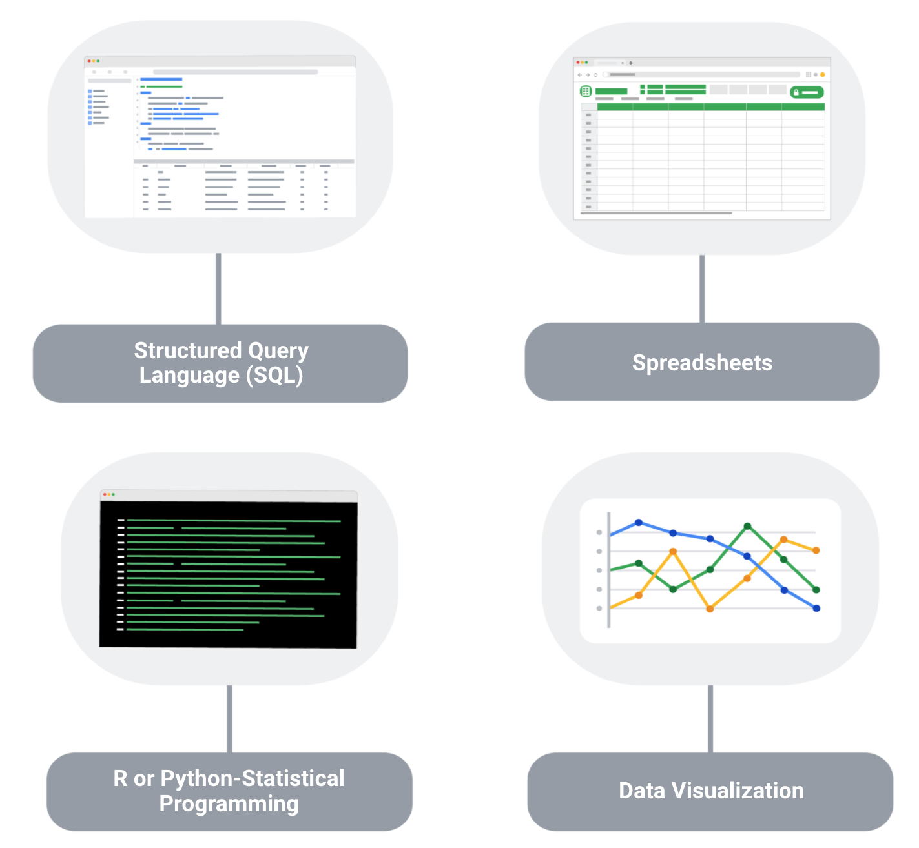

**1. Structured Query Language (SQL):** SQL is considered a basic skill that is pivotal to any entry-level data analyst position. SQL helps you communicate with databases, and more specifically, it is designed to help you retrieve information from databases. Every month, thousands of data analyst jobs posted require SQL, and knowing how to use SQL remains one of the most common job functions of a data analyst.

**2. Spreadsheets:** Although SQL is popular, 62% of companies still prefer to use spreadsheets for their data insights. When getting your first job as a data analyst, the first version of your database might be in spreadsheet form, which is still a powerful tool for reporting or even presenting data sets. So, it is important for you to be familiar with using spreadsheets for your data insights.

**3. Data visualization tools:** Data visualization tools help to simplify complex data and enable the data to be visually understood. After gathering and analyzing data, data analysts are tasked with presenting their findings and making that information simple to grasp. Common tools that are used in data analysis include Tableau, Microstrategy, Data Studio, Looker, Datarama, Microsoft Power BI, and many more. Among these, Tableau is best known for its ease of use, so it is a must-have for beginner data analysts. Also, studies show that data analysis jobs requiring Tableau are expected to grow about 34.9% over the next decade.

**4**. **R or Python programming:** Since only less than a third of entry-level data analyst positions require knowledge of Python or R, you don’t need to be proficient in programming languages as an entry-level data analyst. But, R or Python are great additions to have as you become more advanced in your career.

## **Key takeaway**

As a data analyst, you are often asked to collect and analyze data with a specific purpose in mind. Knowing which platform and language to use helps you analyze the data to decipher which information is important, to probe for any anomalies, prepare questions, assess risks, and so much more.

# Adding soft skills to your resume

There is more than just data when it comes to being a data analyst—there are plenty of soft skills that can set you apart from other candidates so that potential employers will notice you and know that you have the ability to succeed in this role. Here are some of the most common soft skills you will find in an entry-level data analyst resume.

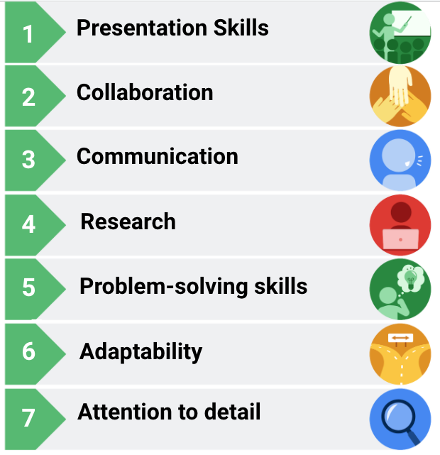

List of data analytics skills/characteristics next to icons.

Presentation skills, collaboration, communication, research, problem-solving skills, adaptability, attention to detail.

1. **Presentation skills**

Although gathering and analyzing data is a big part of the job, presenting your findings in a clear and simple way is just as important. You will want to structure your findings in a way that allows your audience to know exactly what conclusions they are supposed to draw.

2. **Collaboration**

As a data analyst, you will be asked to work with lots of teams and stakeholders—sometimes internal or external—and your ability to share ideas, insights, and criticisms will be crucial. It is important that you and your team—which might consist of engineers and researchers—do your best to get the job done.

3. **Communication**

Data analysts must communicate effectively to obtain the data that they need. It is also important that you are able to work and clearly communicate with teams and business leaders in a language that they understand.

4. **Research**

As a data analyst, even if you have all of the data at your disposal, you still need to analyze it and draw crucial insights from it. To analyze the data and draw conclusions, you will need to conduct research to stay in-line with industry trends.

5. **Problem-solving skills**

Problem-solving is a big part of a data analyst’s job, and you will encounter times when there are errors in databases, code, or even the capturing of data. You will have to adapt and think outside the box to find alternative solutions to these problems.

6. **Adaptability**

In the ever-changing world of data, you have to be adaptable and flexible. As a data analyst, you will be working across multiple teams with different levels of needs and knowledge, which requires you to adjust to different teams, knowledge levels, and stakeholders.

7. **Attention to detail**

A single line of incorrect code can throw everything off, so paying attention to detail is critical for a data analyst. When it comes to understanding and reporting findings, it helps if you focus on the details that matter to your audience.

### **Adding soft skills to your resume**

Here are a few ways that you can add soft skills to your resume:

1. Analyze your previous work experience and find opportunities to insert a soft skill. For example, if you worked in a restaurant, you could emphasize your communication and adaptability skills that you utilized to effectively function during peak hours.
2. Call attention to your problem-solving, presentation, research, and communication skills in previous projects or relevant coursework.
3. Add a mix of soft and professional skills in the skills or summary section of your resume.